25.24: Because the density does not change, volume stays the same, so 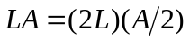 and the area is halved. So the resistance becomes:
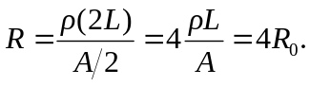
That is, four times the original resistance.

